**Random Positioning Machine Assembly Guide**

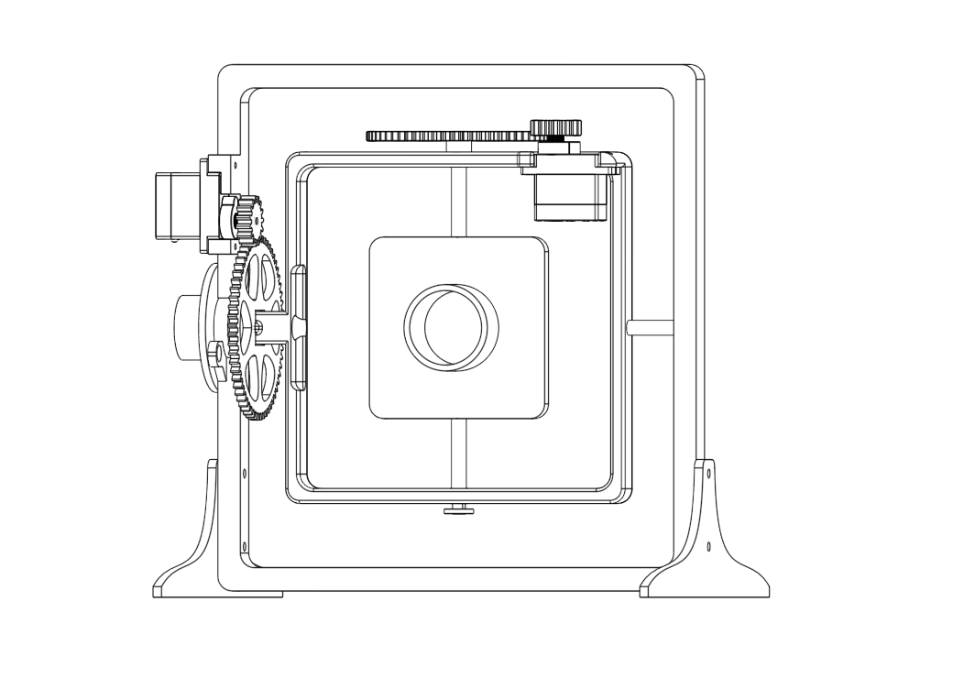

Contents

1. Parts 2

2. Step 1 – Inner Frame Assembly 3

3. Step 2 – Attach the Inner Servo 4

4. Step 3 – Outer Frame Assembly 5

5. Step 4 – Attach the Outer Servo 7

6. Step 5 – Attach Stands 7

7. Step 6 – Route Cables 8

8. Step 7 – Electronics 8

This project is opensource, for a copy of this guide, the code and the 3D models for printing go to <https://github.com/CoreElectronics/Random-Positioning-Machine/tree/main>

**Preparation Work**

* 3D print required parts out of PLA and clean up any edges using a file or sandpaper
* Setup MicroPython and install code on the Raspberry Pi Pico (name the code file main.py)
* Carefully attach each of the two Small Gears to a Servo and secure with a bolt
* Solder headers onto the Slip Ring wires if it does not come with headers for connection
* Logo

  Description automatically generatedA purple and black background

  Description automatically generated with medium confidenceSource additional tools/materials needed; a screw driver, strong tape and bolt cutters for cutting off cable ties

# 1. Parts

1x Outer Frame

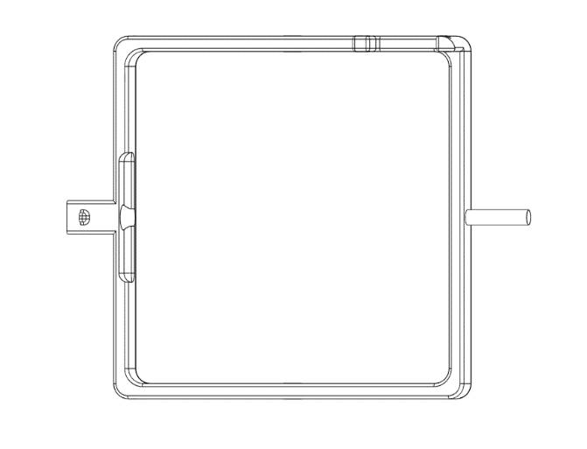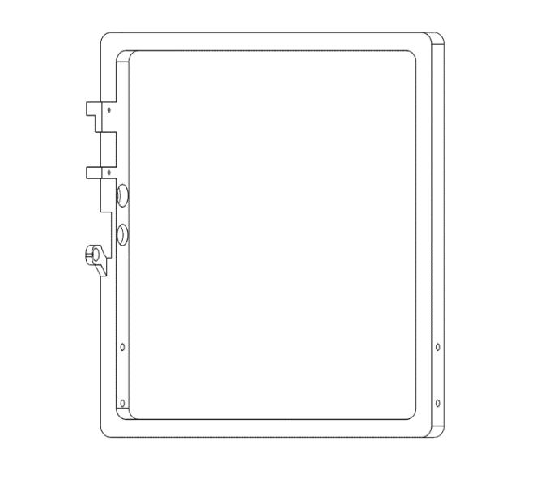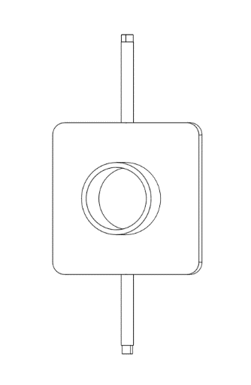

1x Experiment Platform

1x Inner Frame

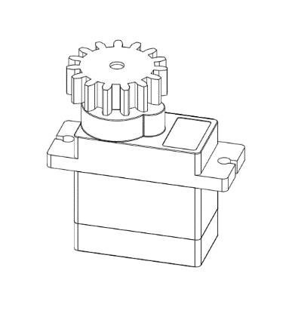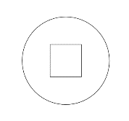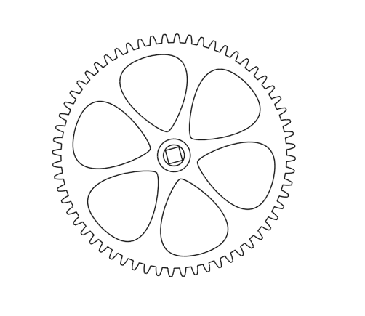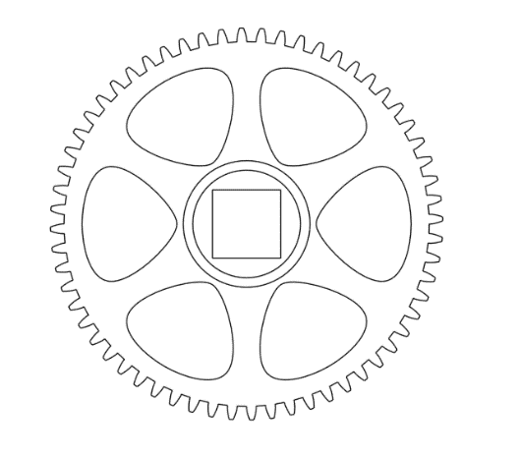

1x End Cap

2x Small Gear Attached to Servo

1x Inner Gear

1x Outer Gear

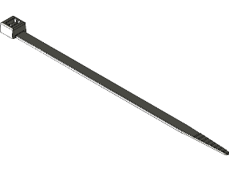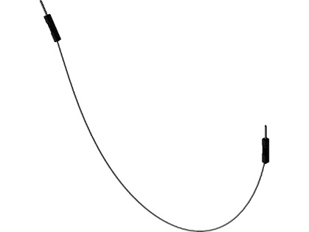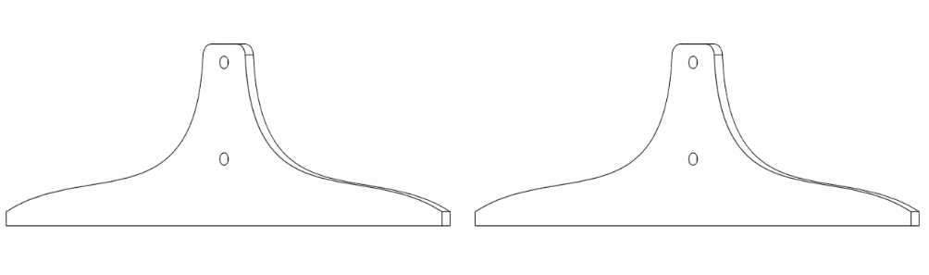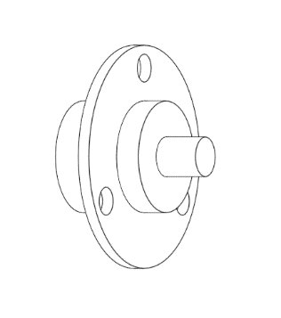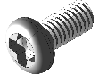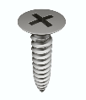

5x Small Cable Ties

1x Breadboard

1x Raspberry Pi Pico

4x Servo Screw

4x M3x6 Bolt

6x Jumper Wire

2x Stand

1x Long Header

1x Slip Ring

# 2. Step 1 – Inner Frame Assembly

Put the Experiment Platform through the holes on the Inner Frame, with the angled square end on the side with the raised supports.

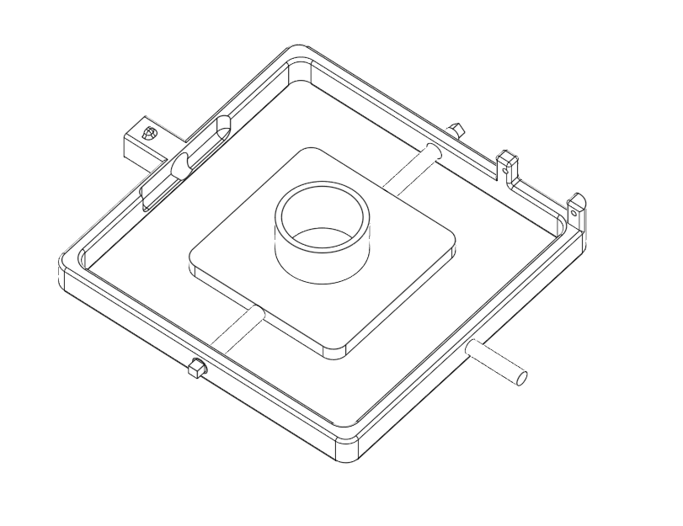

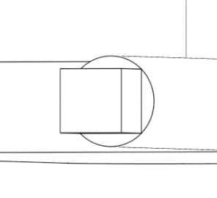

The Experiment Platform has two different ends, one with a straight square (below top) and one with an angled square (below bottom)

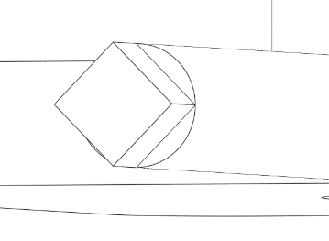

Angled Square End

Straight Square End

Put the Inner Gear on the angled square end of Experiment Platform. Make sure to put it on straight.

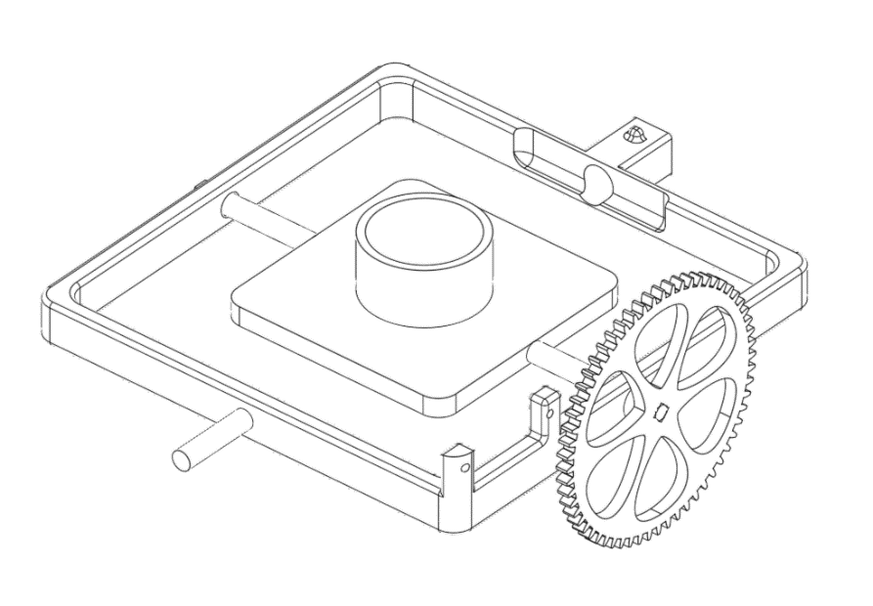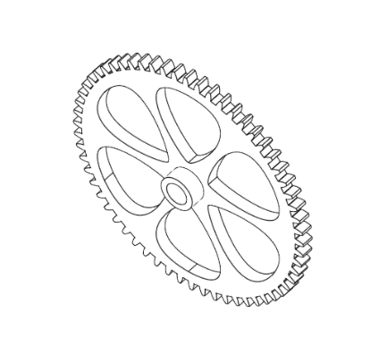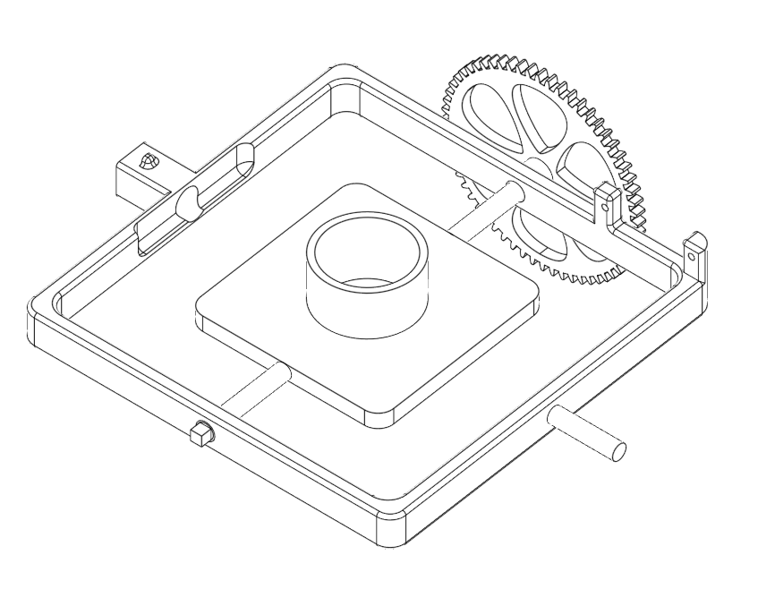

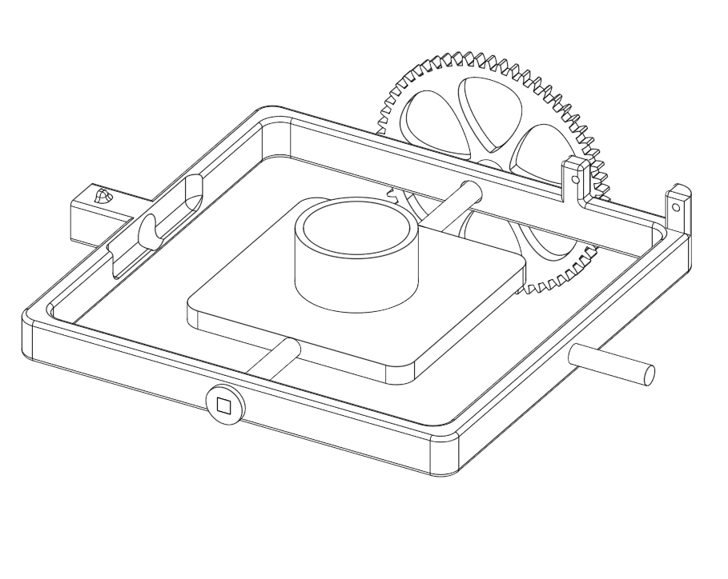Put the End Cap on the straight square end of the Experiment Platform, locking the Experiment Platform in place so it does not move side to side.

# 3. Step 2 – Attach the Inner Servo

Take one of the Servos that has been preprepared with the Small Gear attached using a bolt.

Attach the Servo to the Inner Frame using two of the Servo Screws. Make sure to put the Servo in the correct position so that the Small Gear lines up with the Inner Gear.

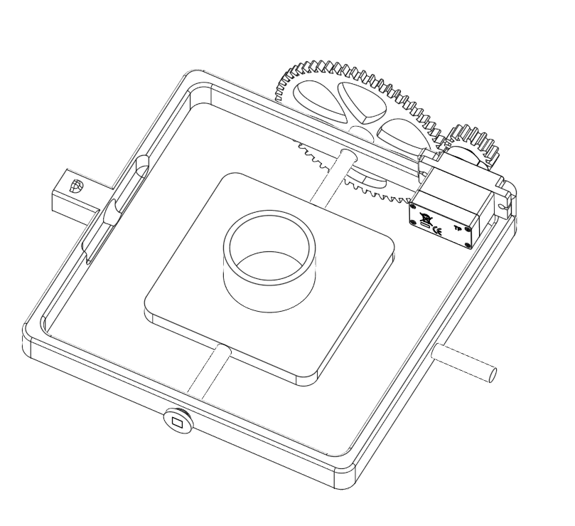

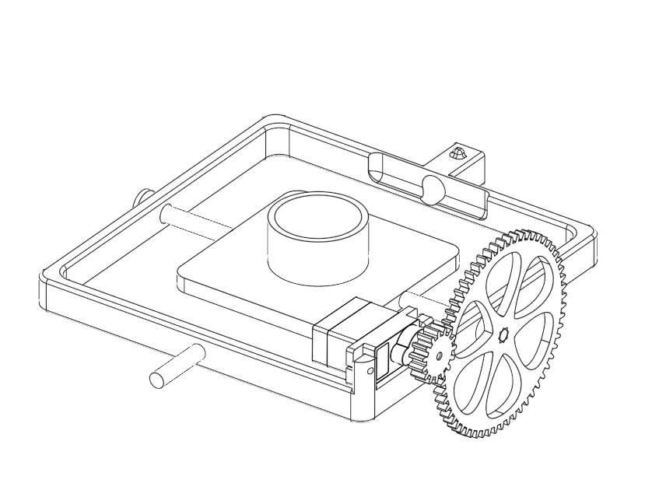

# 4. Step 3 – Outer Frame Assembly

Put the Outer Gear on the Inner Frame. Make sure to put it on straight.

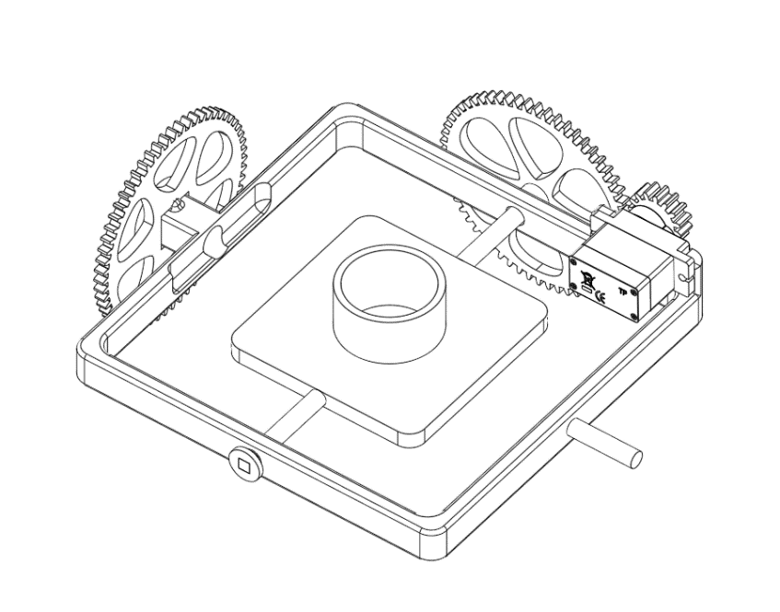

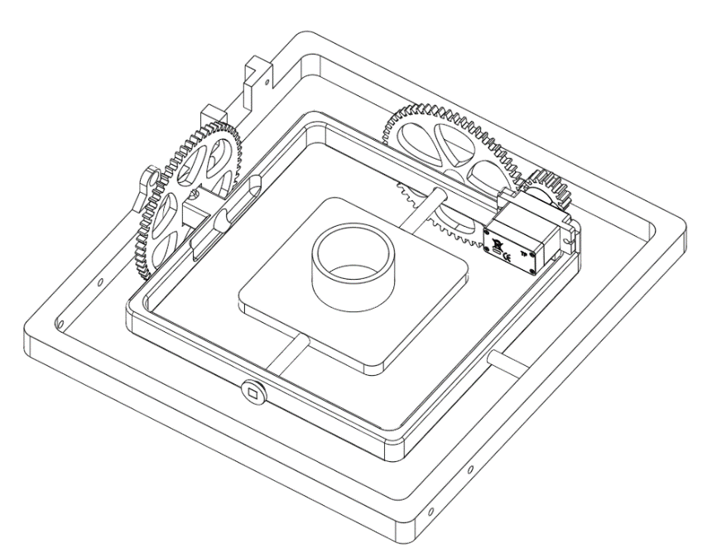Put the Outer Frame on the Outer Gear.

Put the Slip Ring through the Outer Frame into the Outer Gear, making sure to thread the Slip Ring’s shorter wire through the hole to the Inner Frame. Check the wire is not catching when the Slip Ring spins.

Secure the Slip Ring to the Outer Frame using a cable tie threaded through one of the holes on the Slip Ring and the hole on the Outer Frame as shown below.

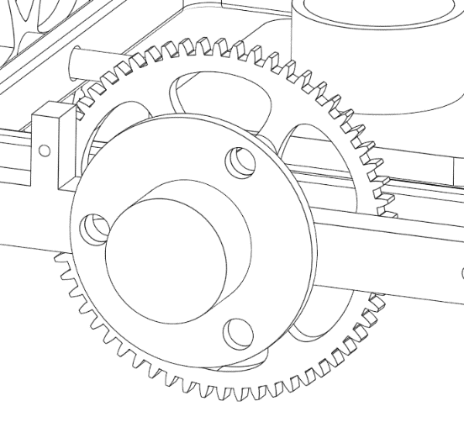

# 5. Step 4 – Attach the Outer Servo

Take one of the Servos that has been preprepared with the Small Gear attached using a bolt.

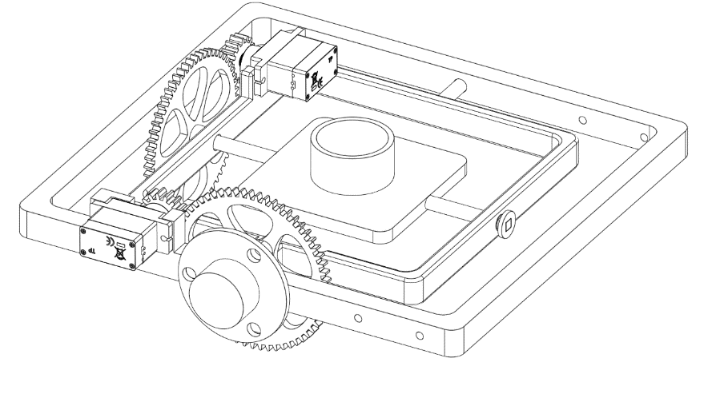Attach the Servo to the Outer Frame using two of the Servo Screws. Make sure to put the Servo in the correct position so that the Small Gear lines up with the Outer Gear.

# 6. Step 5 – Attach Stands

Attach the Stands to the Outer Frame using the M3x6 Bolts.

# 7. Step 6 – Route Cables

Connect the Inner Servo’s cable to the Slip Ring cable:

Brown -> Black

Red -> Red

Orange -> Yellow

Use tape and cable ties to attach the connected cables to the outside of the Inner Frame making sure that it will not catch on anything when the frames are spinning. If the connected cables are too long you can wrap part of them a couple of times around the Inner Frame to make it shorter when you are securing them.

# 8. Step 7 – Electronics

Place the Raspberry Pi Pico in the Breadboard with the USB end facing outward. Using the Jumper Wires connect 5 Volt power (VBUS), ground and signal pins 15 and 16 to the bottom part of the Breadboard where the cable from the Slip Ring (which is connected to the Inner Servo) and the cable from the Outer Servo will be connected to the Pico. Once everything is connected, plug the USB cable into the Pico and a power source.

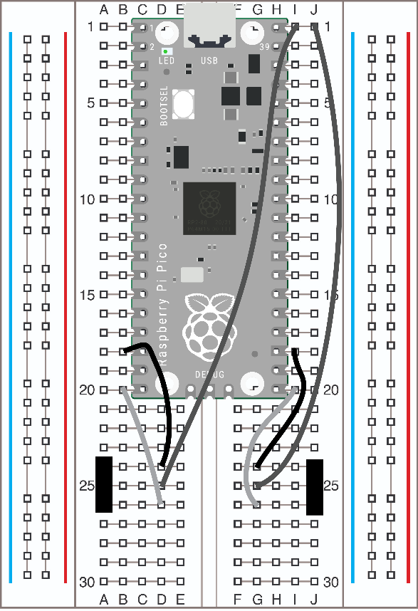

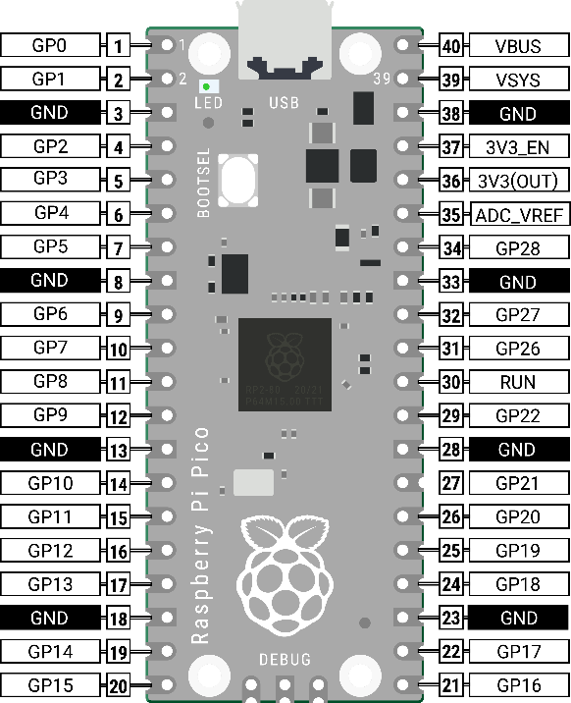

**Cable Colours**

**Outer Servo Slip Ring**

Brown -> Ground Black -> Ground

Red -> Power (5V) Red -> Power (5V)

Orange -> Signal GP15 Yellow -> Signal GP16

Slip Ring

Outer Servo

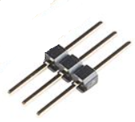

The Outer Servo cable is connected to the breadboard using the Long Header